## **MARK5826 Product Analytics**

**Individual Final Report**

# **Individual Project for Start-up Idea**

**Group 9**

|  |  |
| --- | --- |
| **Student ID** | **Group Member Name** |
| z5058737 | LI, Jiayue |
| **z5142161** | **YONG, Danica Huei Ye** |
| z5146256 | SONG, Lianshuai |
| z5130583 | HU, Han |
| z5192627 | ZHANG, Lidan |

DATE: 11 AUG 2019

1. Product Identification

Without a doubt, ageing is a natural progression of life we all will grow old one day and even though in countries in China where the one child policy has been abolished more and more adults are just having one child in order to focus on their careers or lifestyles. Today we have a longer life expectancy compared to others decades ago because of better healthcare and more awareness of how to live longer. By just doing the math, one child per family is not enough to replace both parents in the workforce and this is concerning as seen in the infographic below. Therefore, we decided to focus on a problem related to the elderly.

1. Deep Understanding of the Problem

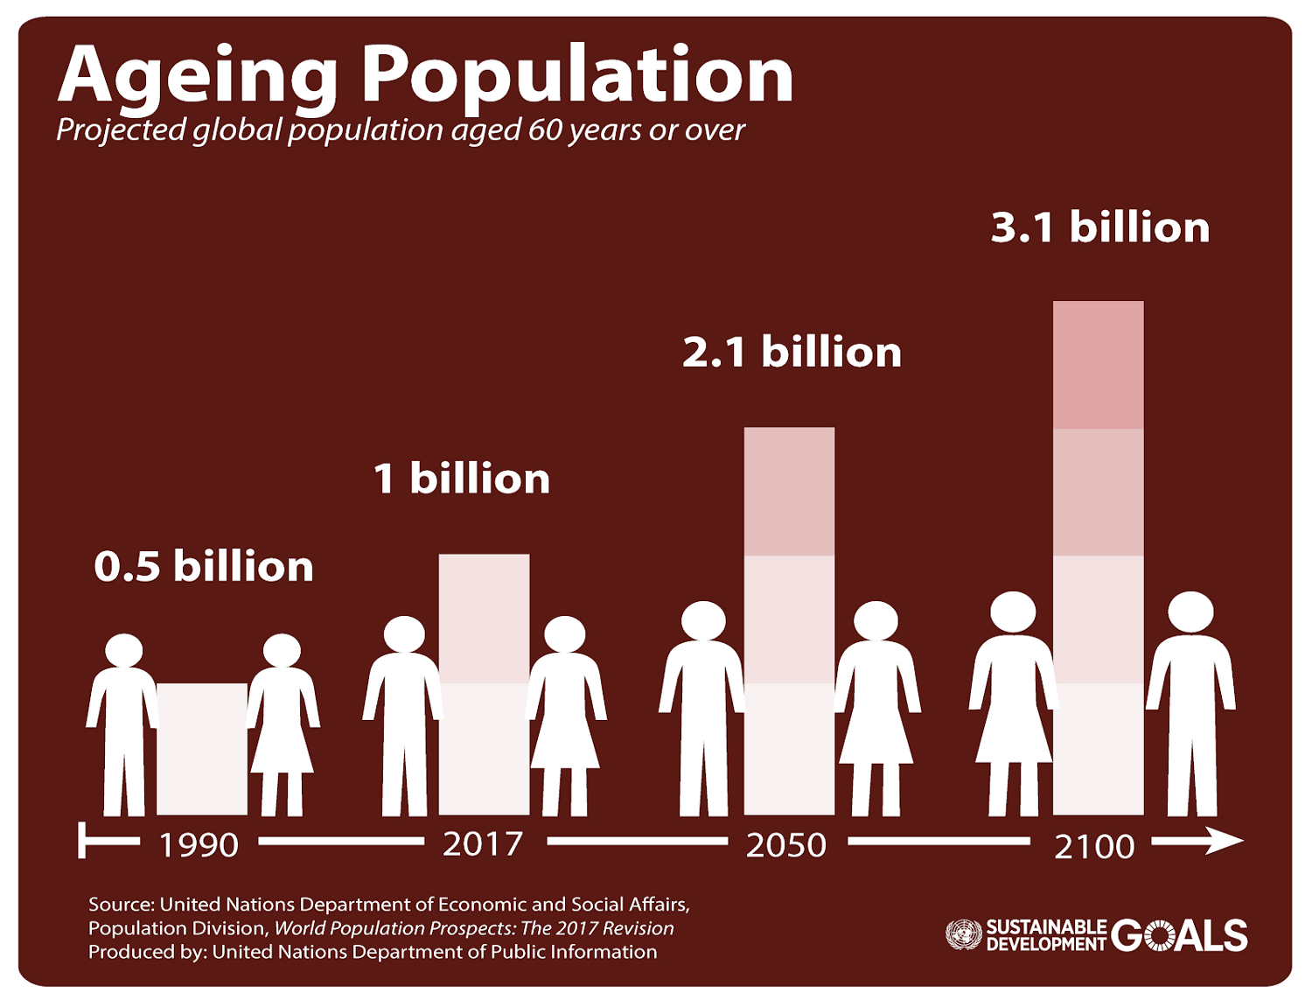

**Image 1: Ageing Population**

As seen in Image 1, the infographic shows how the ageing population will continue to grow in large numbers. With countries such as Japan and Hong Kong that have the lowest birth and death rates, which contributes to a growing ageing population. The infographic above shows that by 2100, the ageing population would have tripled from 2017. This is very worrying as there will be an imbalance ratio of elderly to births.

As a group, we also worry about the problems that our grandparents or parents might face once they have reached a certain age that they might struggle with daily tasks. Especially when our grandparents might accidentally slip or develop dementia, we decided to focus on the problem of aiding them in daily tasks. In addition, we noticed that the application market for the elderly is not saturated and that there is a market for our products.

1. Solution Search

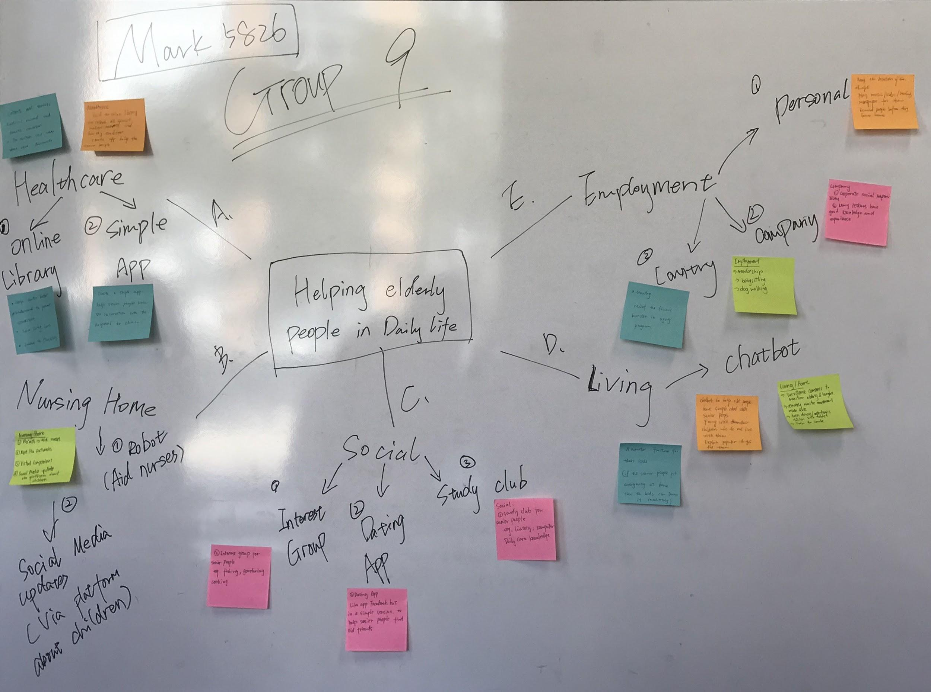

**Image 2: Whiteboard Ideation**

From Image above, my group and I thought about the different problems that the elderly face in their daily lives. We chose five areas that were distinct from each other and yet still overlapping such that it targeted every single aspect of their daily life.

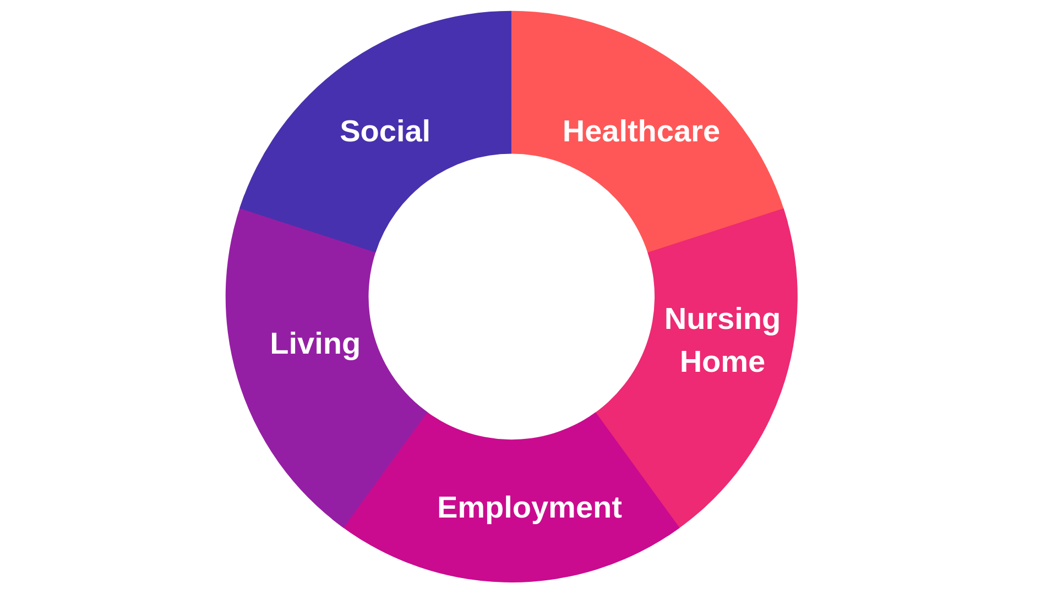

**Image 3: 5 Areas of Focus**

There are five areas that we focused on to help enhance the elderly’s daily lives, social, healthcare, living, nursing home and employment.

In order to keep the elderly active both mentally and physically, we decided to have a Social area that focuses on keeping the elderly entertained. There were several ideas to keep the elderly sociable such as having an internet club or a dating application. The idea that we really liked was creating a dating application for senior citizens, where seniors find friends and companions to do activities together, mainly just to create a social life for the elderly.

Healthcare is such an important area for the elderly as the older they are, the more they require. The idea that we were invested in was creating an application where the elderly could set up appointments through the application, have the details of their medical history and medical records stored in the application.

For the elderly who lives alone at home or an apartment, there are many difficulties that may arise such as falling, intruders or even fires. The idea that we found that solved many of these problems was a low-cost robot that aids the elderly to prevent any accidents.

Even though those that live in nursing homes are cared for all around the clock, due to many problems such as not enough staff being able to be around the elderly residents twenty-four-seven. The idea that we liked was creating an application which had categories to help lift the mood of the residents, decrease chances of dementia and increase mobility through music.

Retiring for seniors can be hard especially not having a job after working for many years. For employment, the idea is to give them options of areas where they can continue working and contribute back to the society.

1. Product Idea

Market Trend of Elderly Care AI Technologies

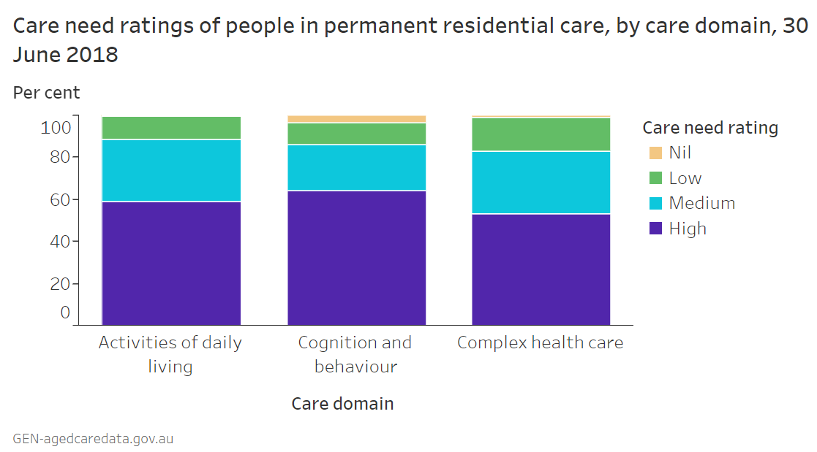

**Image 4: Graph of care needs rating**

The market for artificial intelligence for nursing homes is quite new and not as developed so there aren’t many applications that are targeted for the elderly. However, Forbes reported that this market is slowly heating up as startups and companies realize that they have neglected this industry, slowly they are investing in creating devices and applications to aid the elderly in their daily lives. From the graph above, we can see that a large percentage of residents require high care for daily activities, cognition and health care, there is a market.

Competitor Analysis

|  |  |  |  |  |
| --- | --- | --- | --- | --- |
| Company |  |  |  |  |
| Summary | A guided meditation app to help reduce stress and enhance wellbeing. | Music Therapy application that helps regulate heartrate, blood pressure. | Improve a user's cognitive health by administering a range of training programs | An online brain training app created by a team of international neuroscientists |
| Target User | Everyone | | | |
| Strength | Beautiful features,  Easy layout | Integrates with Apple watch, Gamifies your progress | There is a tailored program for those above 55 years old | Top neuroscientists created & develop the exercises |
| Weakness | Yearly subscription | | | |

**Table 1: Competitor Analysis**

For Calm, it is used to reduce stress and improve wellbeing. Its benefits are that it has a calming layout and is easy to use. For Humm.ly, it is combines music therapy with science and recommends music based on heart rate and blood pressure. Its benefits are that it can be connected via Bluetooth to wearable devices. For Cognifit and BrainHQ, both are cognitive brain workouts however they are different as one has a specific program that is targeted for those above fifty-five years old and the other has neuroscientists that always create exercises due to research. These competitors’ target market is for everyone and its major disadvantage is that all these applications need to pay a monthly or yearly subscription.

Customer Analysis

The aim of this application is two-fold: Nurses will use the application based on the activities and the music will be dependent on the resident’s mood and activities.

|  |  |
| --- | --- |
| Nursing Residents | Nurses |
| Residents that have been diagnosed with depression, dementia or low mobility. | The initial user of the application to select the music and activities. |

**Table 2: Customers**

An example of a nursing resident is Annie Huang, who is showing early symptoms of dementia, she is quite active and is fifty-five years old this year. Nurse Angel will ask her and her children what music she likes to listen to so that she can input this in the application to create a playlist of her favorite music.

An example of the nurse is Nurse Angel who takes care of nursing resident Annie, will be able to select music based on the mood of Annie and allocate time for her to do her cognitive exercises daily. At the same time, nurses will also arrange activities for the residents from the template that is present in the application. Nurse Angel can arrange a small group of five residents who are above sixty-five years old to learn the piano, which helps improve their hand functions and strengthen their hand muscles.

Customer Journey

* Group Activity & Personal Room

Depending on whether it is during a group activity or in the resident’s room alone, nurses will be able to select music based on the atmosphere. At the same time, if the resident is feeling depressed or down then nurses can select the residents’ personal playlist of music that they or their children have chosen for them.

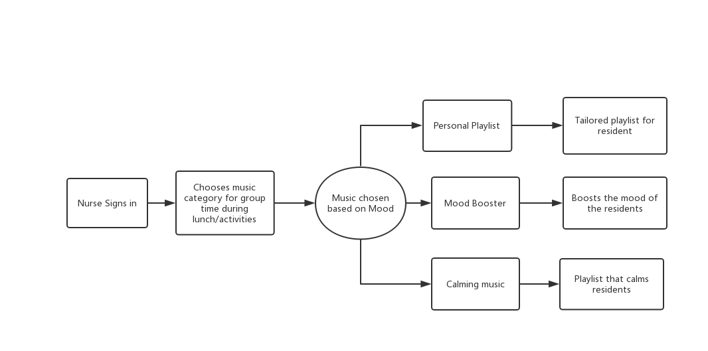

**Flowchart 1: Nurses customer journey (music)**

1. Nurse logs in to the application
2. Since it is an evening activity where everyone is gathered together
3. The application recommends calming music to wind down
4. The nurse will choose the recommended category
5. If it is for residents during their alone time, then nurses will choose the residents’ personal playlists.

* Activities for Residents

Nurse choosing/planning activities for the residents by choosing from three different categories Instruments, Low-Intensity Workout and Coloring. Depending on the activities, these activities will aim to improve their mobility, reflexes and keep their mind active.

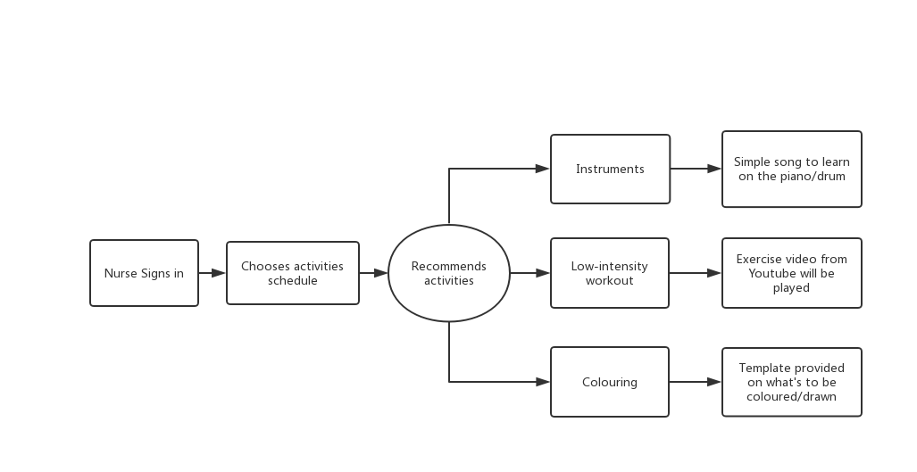

**Flowchart 2: Nurses customer journey (exercises)**

1. Nurse logs into the application
2. If the nurse wants to plan activities for residents for the whole week, she can choose from three choices: Instruments, Workouts or Coloring
3. For instruments, it will provide residents with a simple song for residents to learn using instruments.
4. For low-intensity workouts, this is for the residents who are quite active and to improve blood flow of residents. These videos will be recommended from YouTube.
5. For coloring, a template will be recommended for the nurses to print out for the residents to color.

* Game Workout

This is for residents who have dementia, the application will recommend brain exercises for the different stages of dementia.

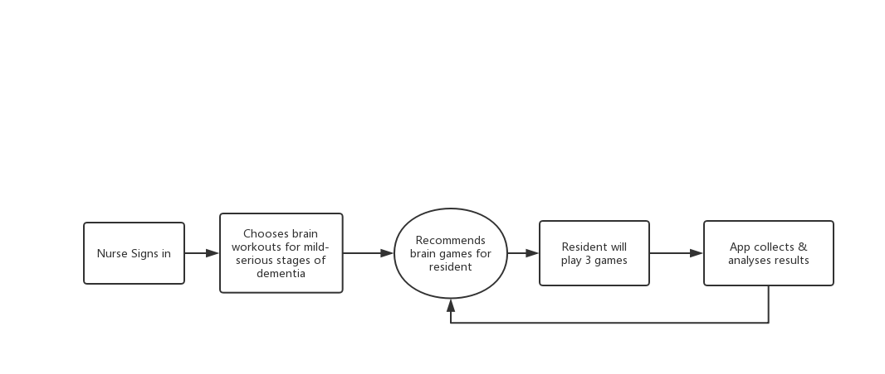

**Flowchart 3: Brain Games flow**

1. Nurses sign in
2. Depending on what stage of dementia the resident is in the application will recommend three brain games a day
3. The application will then collect and analyse the result and tailor the games.
4. Product Feature & Test

It is called MINT as it is meant to be a refreshment for nursing residents when they are feeling down and to encourage them to be active.

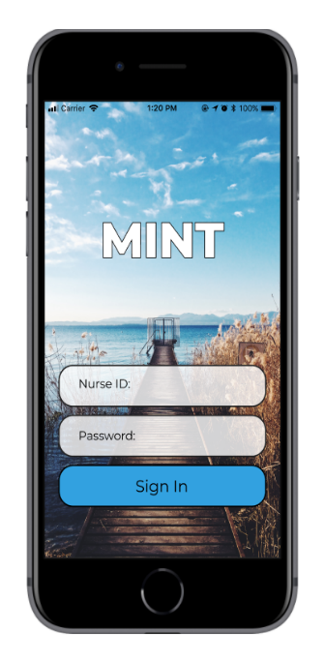Front End Design

1. This is the login page for nurses

**Prototype 1: Login Page**

1. They will be able to check the patients who are under their care as seen on the left-hand side and select the profile of their patients as seen on the

right hand side of the picture. Nurses will be able to select their patients and check what kind of music and activities they like as well as the stage of dementia they are at.

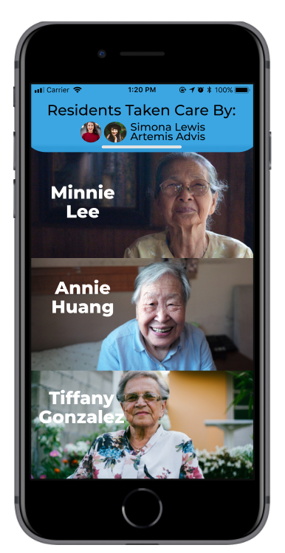 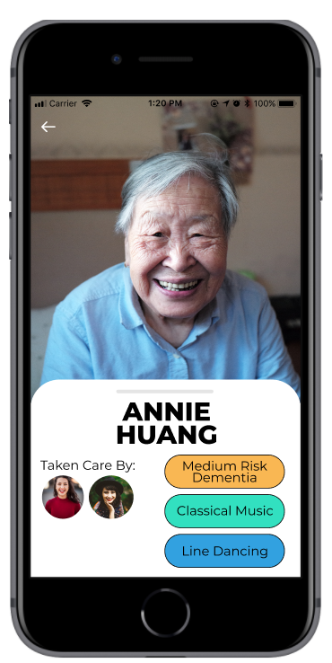

**Prototype 2: Resident List Prototype 3: Resident Profile**

1. Depending on the mood of the patient and the time of the day, nurses will select from either three buttons above which will show them to the three categories such as cognitive exercises, calming music and activities.

For cognitive exercises,

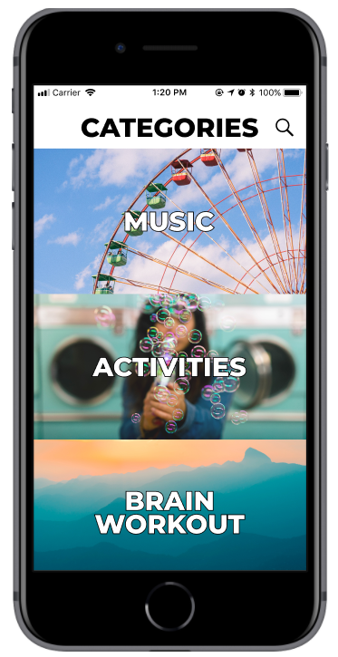

**Prototype 4: Categories List**

1. After selecting a category, they will be linked to the specific category’s page where depending on the mood of the resident or the activity that the nurse has chosen for the day.

* Calming Music

For nursing residents who are feeling depressed or hostile as well as when residents are gathered as a group. The personal playlist will be tailored specifically to the residents’ favorite songs as recommended by themselves or their children if they cannot remember. Also, the application will recommend playlist to the nurses based on the timing of the day and based on the mood of the residents when it is the residents’ alone time.

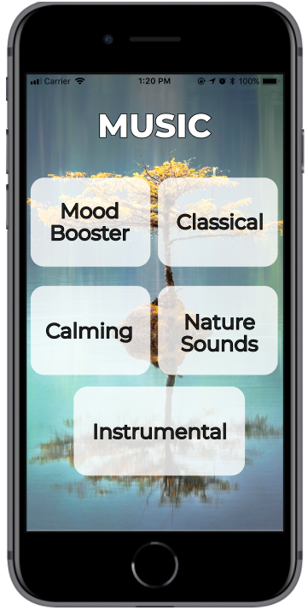 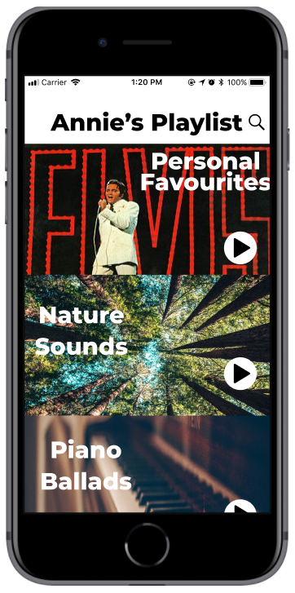 

**Prototype 5: Music Categories Prototype 6: Annie’s Playlist**

* Activities

Nurses will be able to choose from three categories, as seen below, for residents to learn a new instrument and keeping them active both mentally and physically.

1. Instruments: Simple song to learn through instruments to strengthen hand muscles and improve reaction speed

2. Low-Intensity Workouts: Simple exercises recommended from YouTube to encourage residents to be more active

3. Coloring: New coloring templates will be recommended daily to keep their mind active.

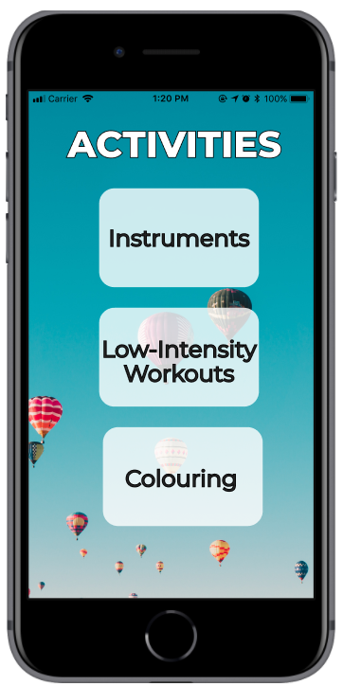 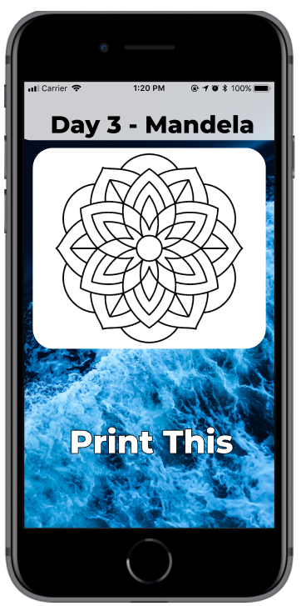

**Prototype 7: Activities Categories Prototype 8: Coloring Template**

* Brain Workout

This section is for residents who are at different stages of dementia, where brain exercises are tailored to help them remember better and hopefully delay their dementia from getting worse. Daily three games based on their stage of dementia will be played and the results are recorded so exercises are tailored to the residents.

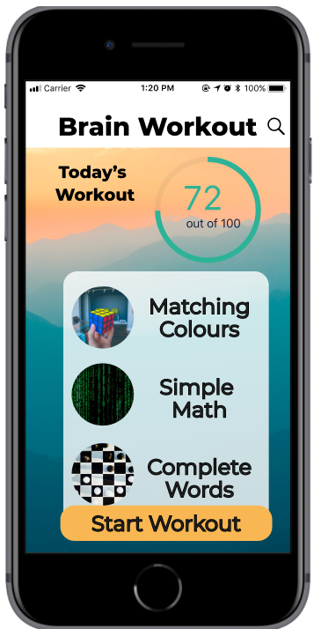

**Prototype 9: Brain Workout**

Survey

I’ve conducted a survey to determine the interest of the application and its features from both nurses who work at nursing homes and others who aren’t nurses. I’ve collated the data and graphs as seen below, among the three main features whether it is of benefit to nurses as well as applicable to others who might send their parents to a nursing home.

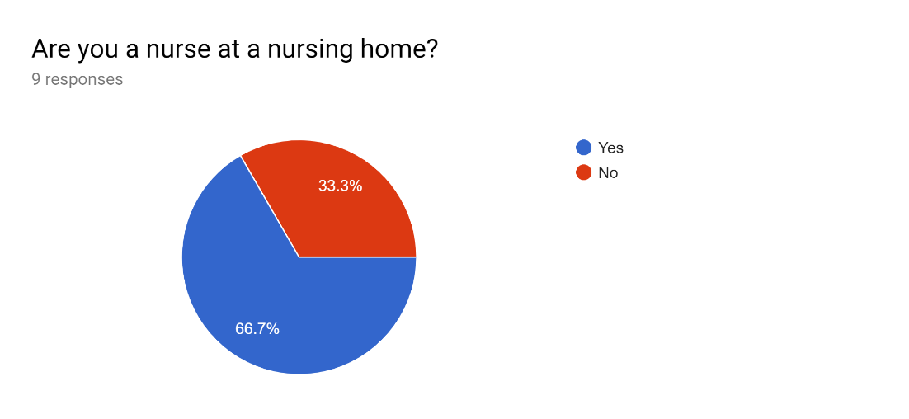

**Graph 1: Demographics of those who took the survey**

There are six nurses that I managed to ask to do this survey and three others that are not nurses. They ranked the order of the features below.

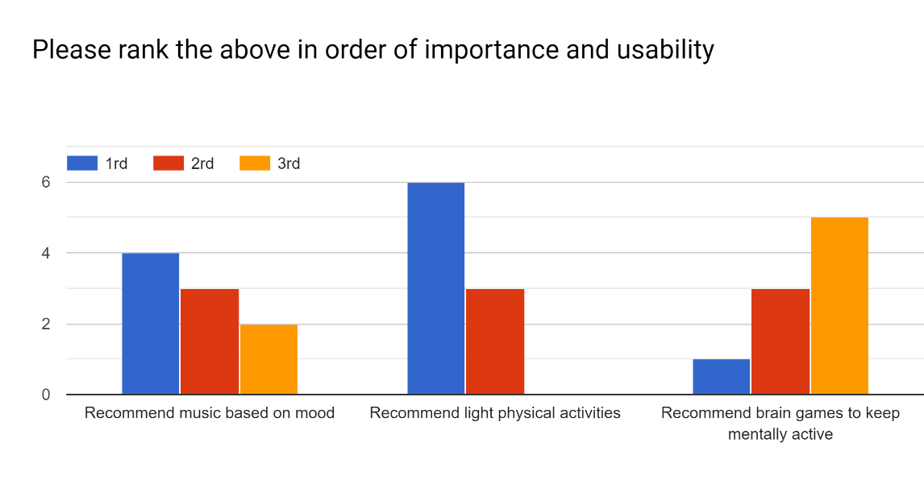

**Graph 2: Ranking the features of importance**

Among all the people I’ve asked to do the survey, they ranked light physical activities as the most important feature for nursing residents followed by music and then brain games.

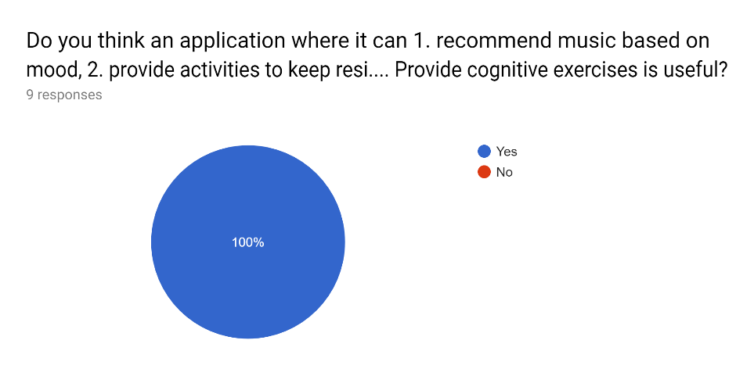

**Graph 2.5: Pie chart for application**

Everyone agreed that having an application with these features is important and useful for nursing residents.

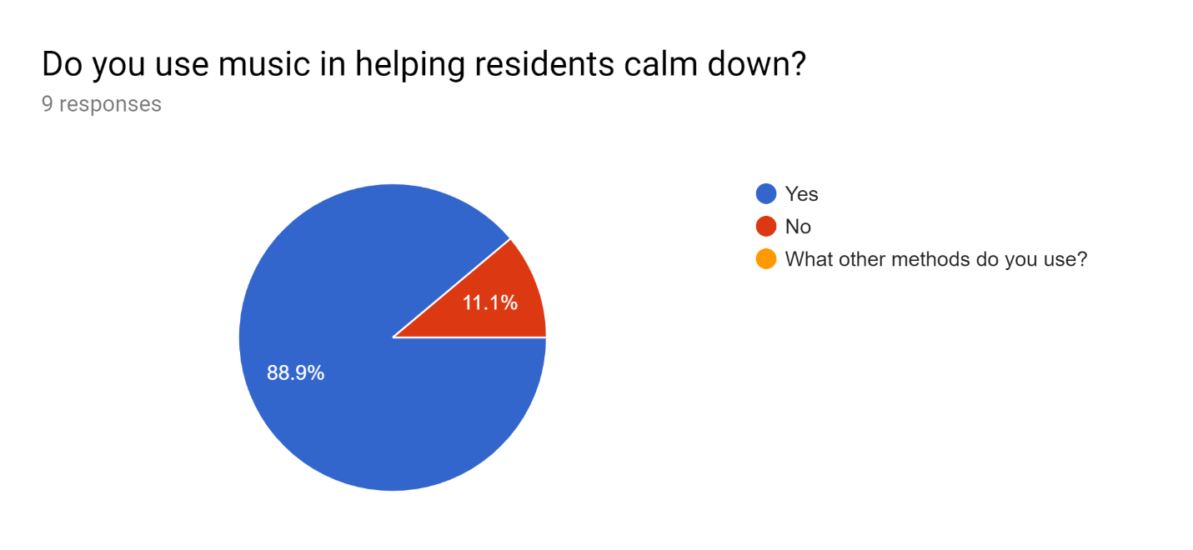

**Graph 3: Does music help calm residents**

Majority says that music does help the residents calm down, especially when residents are feeling down or feeling agitated. There are many cases where residents get territorial over the smallest things therefore causing tantrums and having fits of anger towards nurses or other residents.

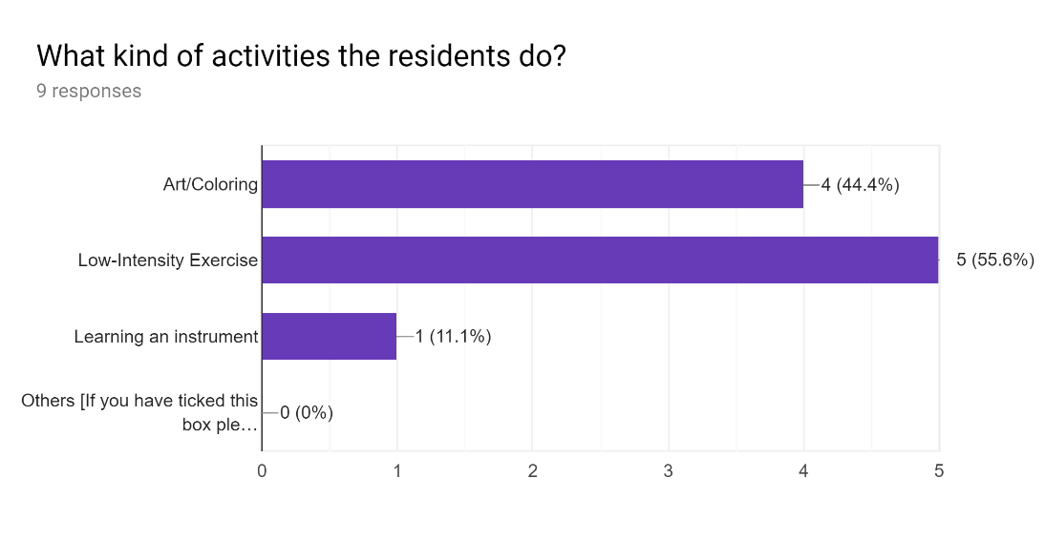

**Graph 4: Activities that residents participate in**

There is a variety of activities that the nursing residents participate in with low-intensity workouts that is the most popular followed by art and coloring and then learning an instrument.

I can infer from the survey that there is an interest and a market for this application and that these features are relevant and useful for nurses and the residents.

1. Start-up Plan

For product development, it would be more accurate if I were to get in contact with facilities managers or even research professionals who are currently doing more research on this. I would like to be able to develop this with someone who has the first-hand experience and it would be easier to create a more accurate and usable application for the nursing homes.

Additionally, it would be better to have a more diverse survey for nurses in nursing homes as well as possibly if I can have majority of the nurses in New South Wales to give me feedback on the application and have a trial basis if possible. This is to limit the chances of the application not being used as there have been many cases of startups who have created good products for the elderly however the elderly is not using the internet as compared to the other generations who are more technology literate. As seen in the graph below, the older they are the less that they use the internet, so for nursing homes where majority of the residents would be those who need high care from nurses. The product or application would be handled by the nurses so as for the application to be used.

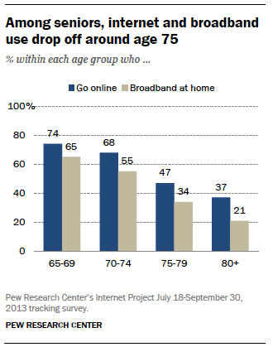

**Graph 5: Ages that use the internet above 65**

I would like the opportunity to create a recommendation system for each of the categories especially for the music section and the low-intensity activities for the nursing residents. If I won’t be able to create a recommendation system for the categories, then the backup plan would be creating some basic videos for low-intensity exercises from researchers who have done plenty of studies on what kind of exercises are the best. Additionally, the music would be selected from researchers who have also done plenty of studies on the usefulness of music therapy (Ray, K.D & Gotell, E, 2018).

I applied for the New Wave Founders Program, hopefully, I will get accepted and will be able to pursue this startup idea and develop it further as there is a market for the elderly market.

Citations

Ray, K. D., & Götell, E. (2018). The Use of Music and Music Therapy in Ameliorating Depression Symptoms and Improving Well-Being in Nursing Home Residents With Dementia. *Frontiers in medicine*, *5*, 287. doi:10.3389/fmed.2018.00287